A000-Asia-China-Shang-Jue-Chüeh-Buffalo Handle-Bronze-1800 BCE

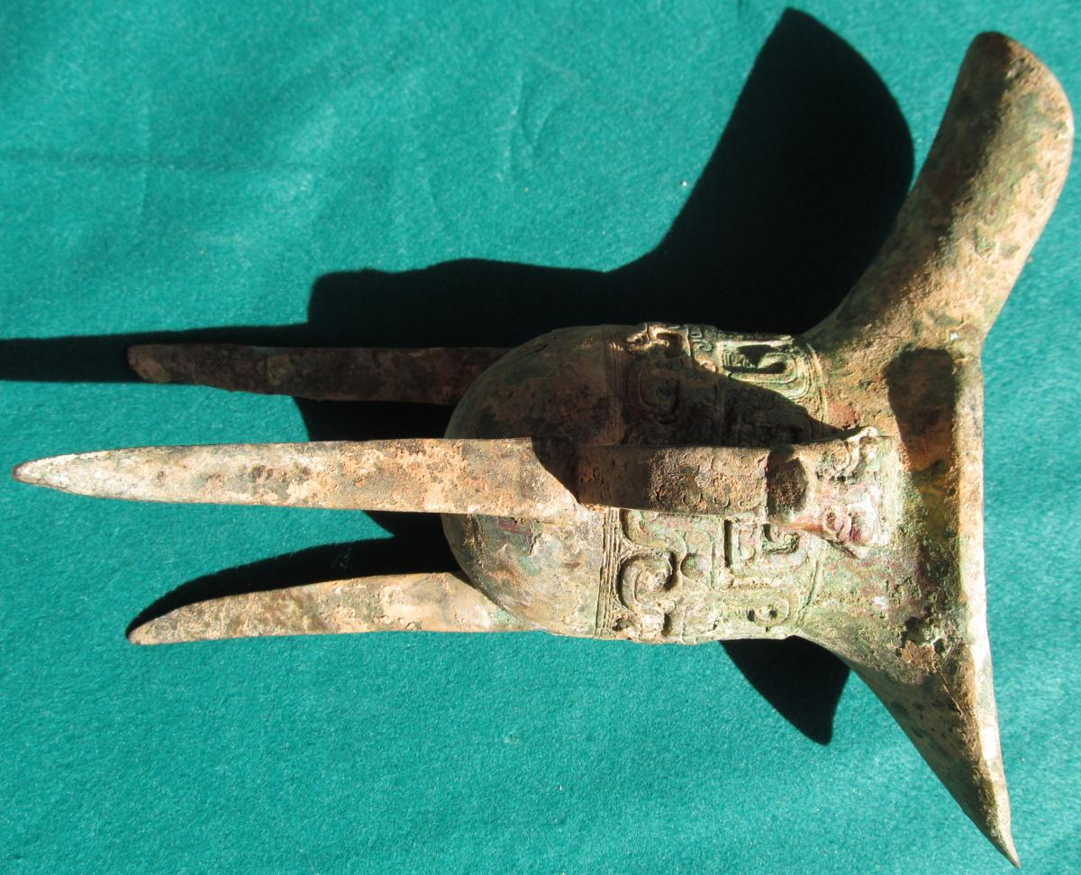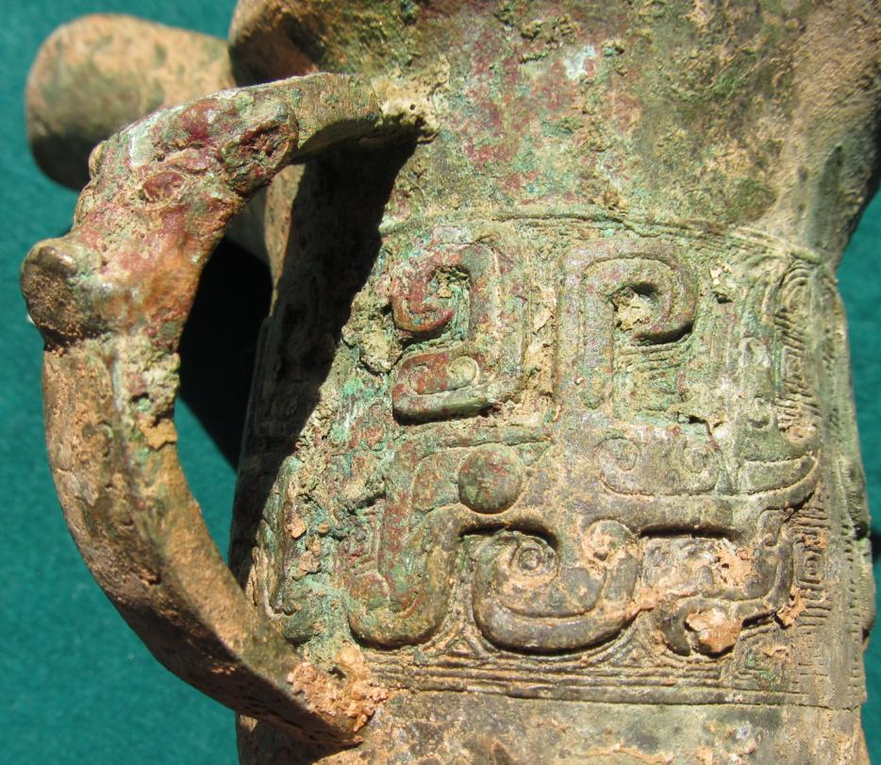

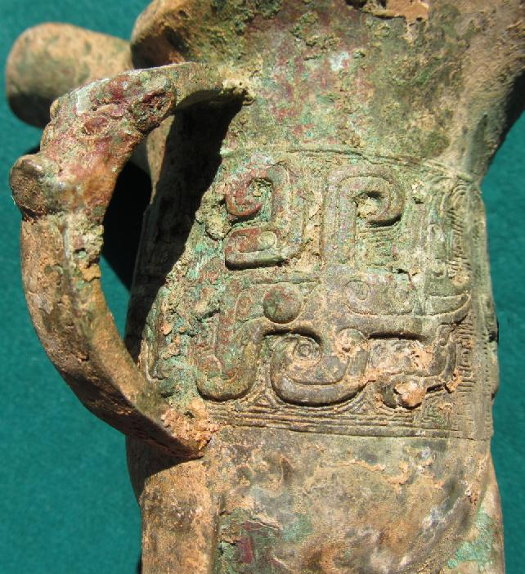 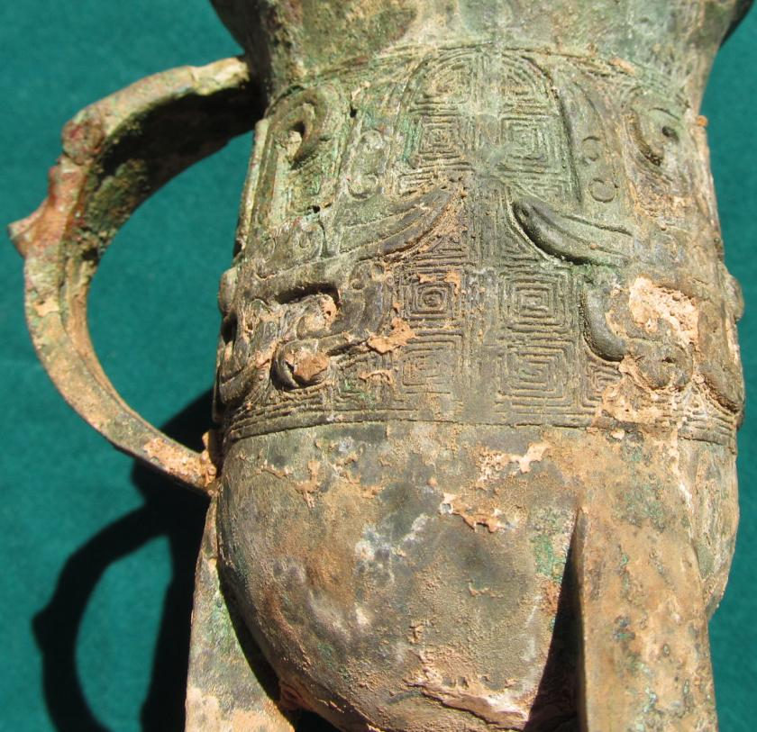

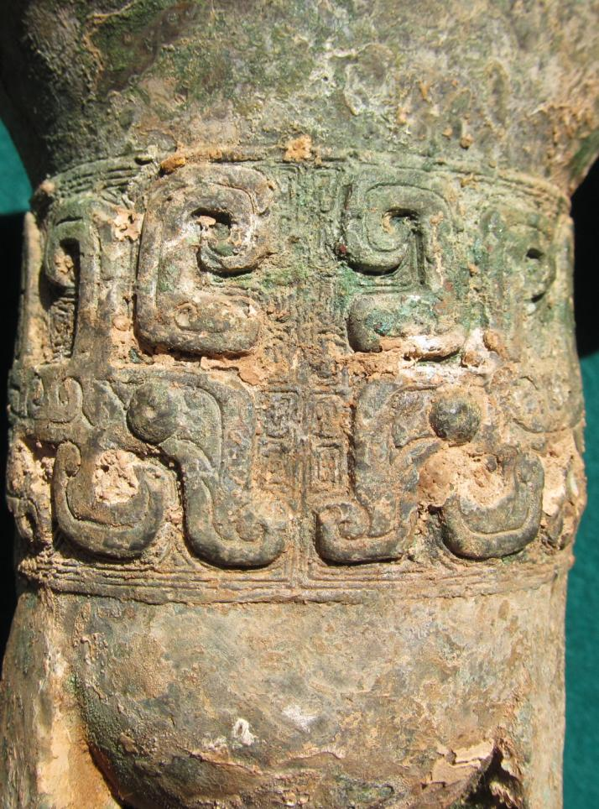

Figs. 1-5. Asia-China-Shang-Jue-Chüeh-Buffalo Handle-Bronze-1800 BCE

Case No.:

Accession No.

Formal Label: Asia-China-Shang-Jue-Chüeh-Buffalo Handle-Bronze-1800 BCE

**Display Description:**

The jue (chüeh, WG) is a type of ancient Chinese pitcher-like containers used for dispensing wine. The jue evolved from a pottery version in the Longshan culture (c 2500–2000 BCE) during the late Neolithic Period. Its bronze version evolved in the Shang (c 1600–1046 BCE) and early Zhou (1046–256 BCE) dynasties. The rim flairs into a U-shaped spout (with capped pillars at its base) on one side and a pointed tail, or handle, flaring out from the opposite side. A buffalo mask which is actually a spirit mask, adorns the handle. This takes the p-lace of the taotie designs usually found on the body of the vessel.

Accession Number:

**LC Classification:**

Date or Time Horizon:

Geographical Area:

**Map:**

**GPS coordinates:**

Cultural Affiliation:

Media:

Dimensions:

Weight:

Condition:

Provenance:

**Discussion:**

**References:**